PURBANCHAL UNIVERSITY

ARYAN SCHOOL OF ENGINEERING

Devkota Sadak, Mid Baneshwor, Kathmandu

The Aryan School
A
FINAL REPORT
ON
"INVENTORY MANAGEMENT SYSTEM"

SUBMITTED BY:
Kabi Raj Bhatt [312729]
Sanjay B.K [312744]
Sameer B.K [312742]
SUBMITTED TO:
DEPARTMENT OF SCIENCE & TECHNOLOGY
BCA-IT( 1st semester)
JUNE, 2026

ACKNOWLEDGEMENT
We express our genuine appreciation to Er. Mithila Bihari Sah, Head of the Department of Bachelor in Computer Application at Aryan School of Engineering and Management, for granting us the chance to construct and present this project proposal detailing an "Inventory Management System". His continuous guidance and encouragement have been deeply vital throughout this process. We are profoundly indebted to our esteemed advisor, Er. Sunil Kumar Ram, for providing critical oversight, constructive assessments, motivating remarks, practical suggestions, and unending assistance across the conceptualization phase of this layout.
We also wish to recognize the excellent contributions and helpful atmosphere maintained by both the instructional and administrative faculty at Aryan School of Engineering and Management. We extend warm thanks to our peers and family members for their enduring motivation, patience, and underlying strength, which proved essential to completing this work smoothly.

Group Members:
Kabi Raj Bhat [312729]
Sanjay B.K [312744]
Sameer B.K [312742]

ii
ABSTRACT
The Inventory Management System represents an interactive terminal-driven program engineered using C programming structures to mimic the core operational movements of modern stockrooms and commercial retail hubs. This specific utility is meticulously planned to automate asset tracking habits, cleanly handling fresh product provisioning, stock reorder modifications, item decommissioning, and ongoing catalog evaluations while ensuring a protected and efficient operating space. Prominent capabilities feature a protected checkpoint verification setup for administrative oversight, automated product identification string generation, instant quantity monitoring, and input data logic validation.
The design highlights clean data grouping practices and smooth operational sequencing, supplying an excellent framework for supervising product indices without errors. By weaving together foundational programming paradigms such as custom structs, programmatic loops, and evaluation conditions, this design offers a realistic remedy for structural commercial supply tracking.
KEYWORDS:
Inventory Management, C Programming, Stock Systems, Login Authentication, Product Management.

iii
Table of Contents
Acknowledge ii
Abstract…………………………………………………………………………………...iii
Table of contents………………………………………………………………………….iv
1. Introduction
1.1 Background 1
1.2 Problem Statement 1
1.4 Application 2
1.5 Features 2
1.6 Feasibility Analysis 3
1.7 System Requirements 4
2. Literature review 5
3. Methodology……………………………………………………………………………6
3.1 System Architecture………………………………………………………………..6
3.2 Algorithm 7,8
3.3 Flowchart 9
4.Result & Discussion 10
4.1 Output and Related Discussion 10
4.2 Work Completed 10
4.3 Limitations 11
4.4 Gantt chart 12
5. conclusion &future enhancement……………………………………………………..13
5.1 Conclusion 13
5.2 Scope for Future Enhancement 13
References ……………………………………………………………………………….14
Appendices………………………………………………………………….15,16,17,18,19
iv
CHAPTER 1: INTRODUCTION
Supply pipeline tracking utilities remain highly crucial within modern corporate commerce, successfully shifting away from paper ledger templates to agile electronic configurations. The Inventory Management System functions as a terminal-driven C application created to provide rapid item processing and volume adjustments via a well-organized and protected control space.

1.1 Background
In contemporary commercial environments, physical product monitoring is noticeably slow and heavily vulnerable to human recording mistakes. Legacy cataloging routines frequently produce mismatched balance numbers and sluggish lookup operations. This software framework updates these workflows via structural C code logic, capitalizing on entities like data structs and storage vectors to establish a highly dependable management tool.

1.2 Problem Statement
Physical stock logging regularly battles systemic issues including unauthorized item adjustments, arithmetic calculation errors, and slow retrieval patterns during item history searches. This implementation mitigates such operational vulnerabilities by embedding a strict operator check screen alongside automated processing logic, cementing data truthfulness and rapid transaction responses.

1
1.3 Objectives
This project is undertaken with the following key objectives:
- To build an operational, menu-driven Inventory Management System using C language structures.
- To enforce secure administration through encrypted logic or credential validation parameters.
- To automatically monitor and update stock volumes accurately.
- To generate clean data tables representing total stock lists in real-time.

1.4 Application
This framework fits the logistical needs of boutique commercial stores, localized supply depots, academic storage closets, and internal corporate tool rooms seeking a lightweight, protected inventory auditing tool.

1.5 Features
- Secure Admin Login: Restricts access to authorized stock managers exclusively.
- New Product Registration: Simplifies the intake and categorization of incoming cargo units.
- Automated Stock and Remove: Handles quantity adjustments and record updates smoothly.
- Real-time Inventory Viewing: Offers an immediate overview of stock levels across the entire catalog.
- Search Product Integration: Locates items instantly using specific product tracking IDs.

2

1.6 Feasibility Analysis
A feasibility analysis was conducted to evaluate the practicality of developing the Inventory Management System. The study focuses on three main areas: economic, technical, and operational feasibility.

1.6.1 Economic Feasibility
The system is economically feasible as it is developed using the C programming language, which is free and open-source. Development tools such as GCC and IDEs do not require any licensing cost. It reduces operational costs by minimizing manual record-keeping.

1.6.2 Technical Feasibility
The system is technically feasible because it is developed using the widely supported C programming language. It uses straightforward array and structure processing without the overhead of heavy backend databases, ensuring it runs rapidly on any standard hardware.

1.6.3 Operational Feasibility
The simple, terminal-driven interface makes the system operationally feasible. Minimal training is required for administrative staff to log in, add stock, update volumes, and generate inventory reports. It significantly outperforms manual logging methodologies.

3

1.7 System Requirements

1.7.1 Software Requirements
- Operating System: Windows / Linux / macOS
- Programming Language: C (C99 standard or higher)
- Compiler: GCC / Turbo C / Code::Blocks / Dev C++

1.7.2 Hardware Requirements
- Processor: Intel Core i3 or superior processing chip
- RAM: Minimum 2 GB (4 GB capacity recommended)
- Storage: Minimum 500 MB unallocated space
- Display: Standard monitor and keyboard setup

4
CHAPTER 2: LITERATURE REVIEW
Inventory management systems have evolved from traditional manual record-keeping methods to automated digital platforms that significantly improve data accuracy, tracking efficiency, and inventory security [1]. These systems enable organizations to monitor stock levels in real time, reduce operational errors, and enhance decision-making processes. Rapid identification of low stock states prevents operational halts, making digitized inventory vital to modern commerce.
The C programming language remains a popular choice for developing system-level applications because of its high execution speed, low memory overhead, and structured programming features [2]. These characteristics make it suitable for building lightweight terminal-based inventory management systems that require efficient resource utilization. It proves that sophisticated management layers can exist without massive computational overhead.
Data management is a fundamental aspect of inventory control systems. Authentication and authorization mechanisms ensure that only authorized personnel can modify inventory records, pricing information, or stock quantities, thereby maintaining data integrity and preventing unauthorized access [3]. In retail situations, separating entry-level workers from master catalog adjustments effectively limits data corruption and internal theft risks.
Modern inventory management software commonly utilizes modular programming concepts, loops, functions, and user-defined structures to organize and process information effectively. Storing inventory records in arrays and structures allows efficient data retrieval and supports stable system performance under increasing workloads [4].

5
CHAPTER 3: METHODOLOGY
The project incorporates a distinct modular lifecycle strategy to preserve system transparency, coding simplicity, and rapid testing routines. Every custom module runs a specified action within the comprehensive Inventory Management System framework.

3.1 System Architecture
The system is organized into distinct functional modules, each implemented as one or more C functions. The modules are as follows:
- Authentication Module: Validates supervisor credentials before granting access to the system dashboard.
- Dashboard Module: The central loop displaying user options and coordinating user input.
- Registration Module: Enforces unique identifier allocation rules for novel item addition and registers names, prices, and volumes into the structures array.
- Update & Remove Module: Evaluates item existence before permitting administrative stock changes (incrementing/decrementing or full deletion).
- Display Module: Renders cleanly aligned data tables showing total stock lists and current counts directly to the terminal screen.

6

3.2 Algorithm
Step 1: Initiate the program environment.
Step 2: Render the introductory title layout.
Step 3: Assign hardcoded management credentials for validation checks.
Step 4: Request user identity tags and security phrase codes.
Step 5: Match the user-supplied text strings against internal storage fields.
Step 6: If strings match, open the core operations console dashboard.
Step 7: If strings do not match, advance the failure tally variable. Enforce a restriction cap of 3 identification attempts. If the cap is reached, kill execution.
Step 8: Display the primary navigation screen featuring options: Add Item, Update Stock, Remove Item, View Inventory, and Exit.
Step 9: Capture the selective entry choice provided by the operator.
If choice matches "Add Item":
Step 10.1: Confirm if free array space exists for new profiles.
Step 10.2: Compute a brand-new item tracking token.
Step 10.3: Record product title strings and supplier details.
Step 10.4: Define the beginning count volume and valuation price.
Step 10.5: Commit product properties into the primary system data array.
If choice matches "Update Stock":
Step 11.1: Request the target item tracking token.
Step 11.2: Parse the storage list for a corresponding product identifier.
Step 11.3: Collect the fresh quantity value adjustment.
Step 11.4: Recalculate and rewrite the saved storage quantity.
Step 11.5: If lookup loop fails, display a missing item warning.

7
If choice matches "Remove Item":
Step 12.1: Request the target item tracking token.
Step 12.2: Parse the storage list for a corresponding product identifier.
Step 12.3: Remove the selected record row and re-align successive array slots.

If choice matches "View Inventory":
Step 13.1: Check if the master stock array count matches zero.
Step 13.2: Print out every registered product profile inside a structured grid table.
Step 14: Upon concluding any secondary branch logic, cycle back to the dashboard layout continuously until an exit directive fires.

8

3.3 Flowchart

Inventory Management System
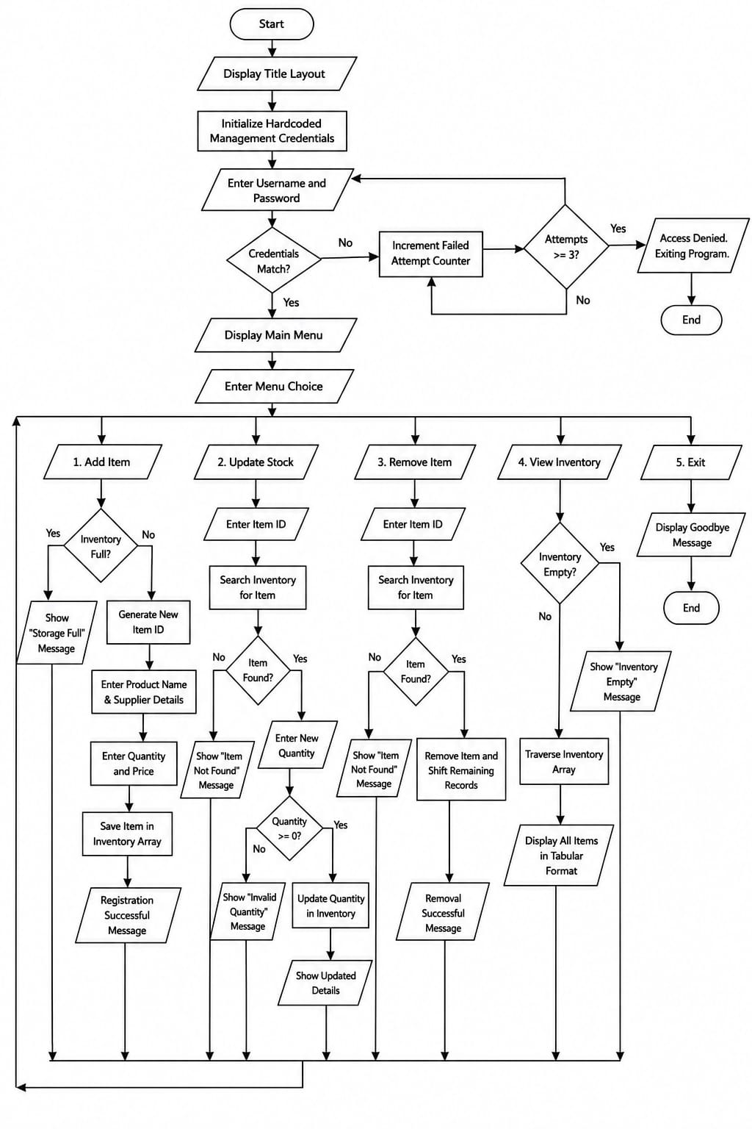
Figure 1: Flowchart of Inventory Management System
9
CHAPTER 4: RESULTS AND DISCUSSION

4.1 Output and Related Discussion
The Inventory Management System was successfully designed and developed using the C programming language. The interactive, terminal-based interface enables fluid transitions between adding new physical items, updating volumes, and printing the entirety of the database to the screen. Execution happens smoothly without lag, confirming that the struct array approach to data handling is highly efficient for targeted scopes.
Testing validated the administrative login boundary, protecting inventory lists from unauthorized changes. Output tables align correctly utilizing C formatting options (`%-10s`, `%-15.2f`), providing readability expected in business terminal applications.

4.2 Work Completed
The expected outcomes were achieved through the completion of the following phases:
- Understanding of inventory management concepts and logic flows.
- System Architecture and Algorithm design formulation.
- C Programming implementation (Loops, Conditionals, Structs).
- Creation of Login, Add, Update, Remove, and View modules.
- Testing logic bounds (e.g. preventing negative inventory input).
- Enhancement of overall data management skills without database reliance.

10

4.3 Limitations
The current iteration of the system faces several constraints:
- Console-based interface only, lacking mouse-driven GUI interaction.
- All data resides in temporary memory; missing file-handling integration to save data permanently across reboots.
- Single-user environment structure limits parallel multi-device use.
- Lacks automated barcode scanning input capability.

11

4.4 Gantt Chart
The project followed a structured development timeline over the semester.

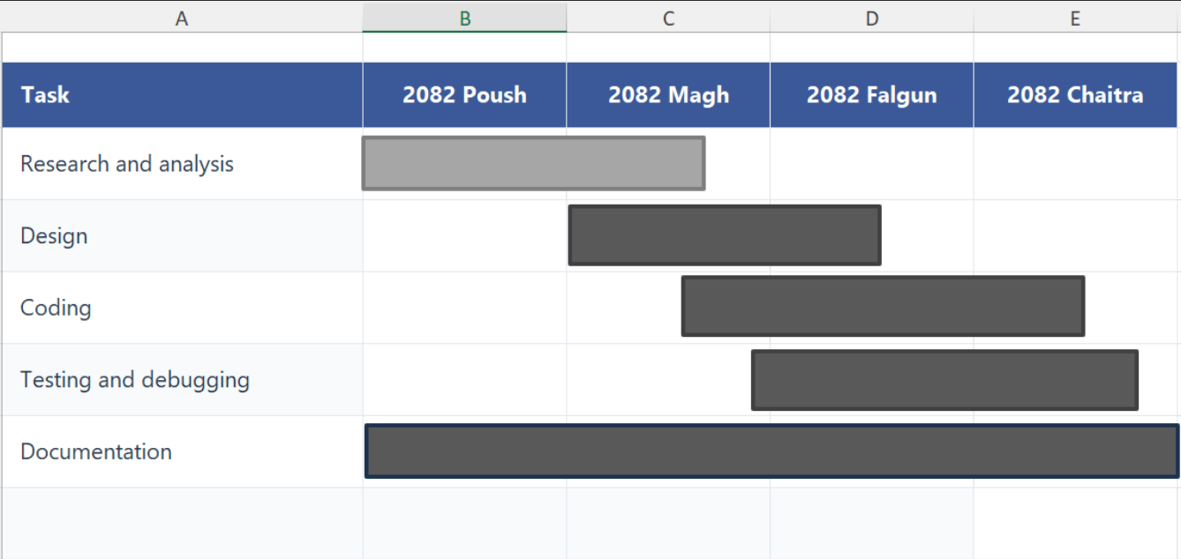

12
CHAPTER: 5 CONCLUSION AND FUTURE ENHANCEMENT

5.1 Conclusion
The Inventory Management System successfully achieves its goal of supplying a structured, automated utility for handling physical item tracking via terminal inputs. By implementing foundational C programming elements—specifically multidimensional tracking via Structs, menu iteration via loops, and boundary protection—it demonstrates how procedural language structures translate directly into robust business tools.
The tool mitigates the errors native to physical ledger management, establishing a platform where stock retrieval, administrative safety, and real-time calculation exist in harmony. Ultimately, the project served as an excellent practical bridge between academic programming theory and real-world application building.

5.2 Scope for Future Enhancement
The system possesses excellent potential for expansion:
- Permanent File Handling: Implementing `fread()` and `fwrite()` directives to lock inventory arrays into text or binary files locally.
- Graphical User Interface (GUI): Migrating logic to modern frameworks (like QT or GTK) for windowed interaction.
- Database Integration: Using SQLite or MySQL to manage vast warehouses containing thousands of SKU records.
- Hardware Connectivity: Reading serialized input directly from USB barcode scanners to expedite the "Update Volume" loop.

13
REFERENCES
[1] B. W. Kernighan and D. M. Ritchie, The C Programming Language, 2nd ed. Englewood Cliffs, NJ, USA: Prentice Hall, 1988.
[2] J. Heizer, B. Render, and C. Munson, Operations Management: Sustainability and Supply Chain Management, 13th ed. New York, NY, USA: Pearson, 2020.
[3] R. S. Pressman and B. R. Maxim, Software Engineering: A Practitioner's Approach, 9th ed. New York, NY, USA: McGraw-Hill Education, 2020.
[4] W. Stallings, Computer Security: Principles and Practice, 4th ed. Boston, MA, USA: Pearson, 2018.

14

APPENDICE
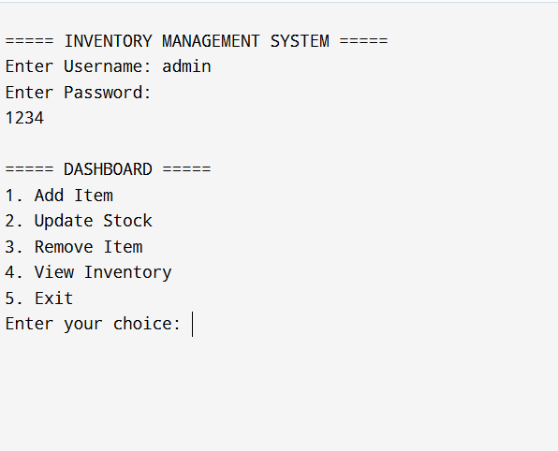
Figure : Login & Main Menu

15
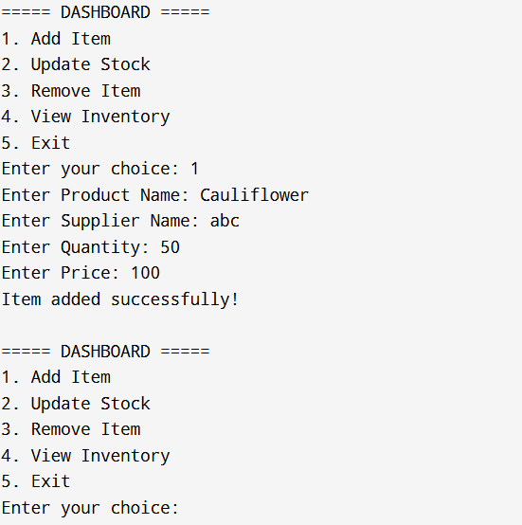
Figure : Add Item from Program.

16
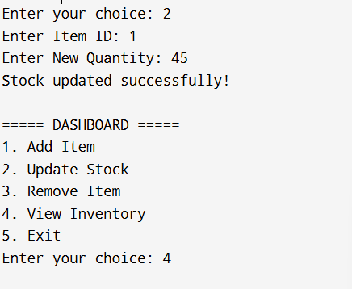
Fig: Update stock

17

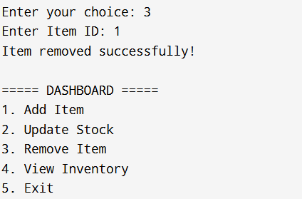f

Fig: Remove items

18
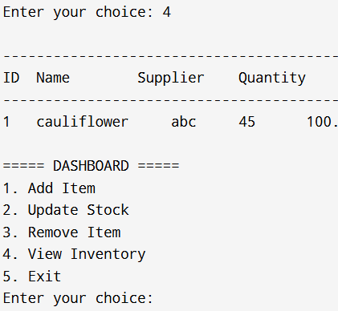

Fig: view inventory

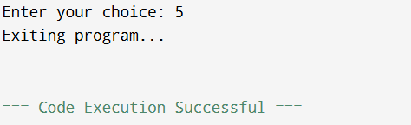

Fig: exit

19

